**Project 1: Racing Car**

Problem Description: ( This is exercise 15.29 of the text)

Write a Java program that simulates car racing, as shown in Figure a. The car moves from left to right. When it hits the right end, it restarts from the left and continues the same process. You can use a timer to control animation. Redraw the car with a new base coordinates (x, y), as shown in Figure b. Also let the user pause/resume the animation with a button press/release and increase/decrease the car speed by pressing the *UP* and *DOWN* keys.

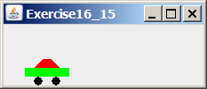 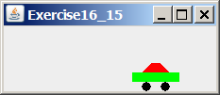 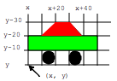

(a) (b)

Design:

(Draw a sketch of UI)

Submit the following items:

1. Submit a hard copy of this document.

2. Submit a UML diagram

3. Submit a screen shot of the application running.

4. Submit a zip file of your source file ( e.g. src)

3. Fill in self-evaluation:

1. Can you draw the car correctly? Yes
2. Is the car moving? Yes
3. Is the car moving circularly? Yes
4. Does the car pause/resume with a button press/release? Yes
5. Does the speed increase and decrease with the UP and DOWN keys? Yes

**Screenshot**

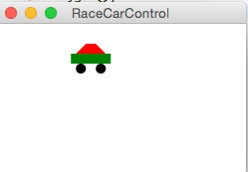

**UML**

